Physical Science
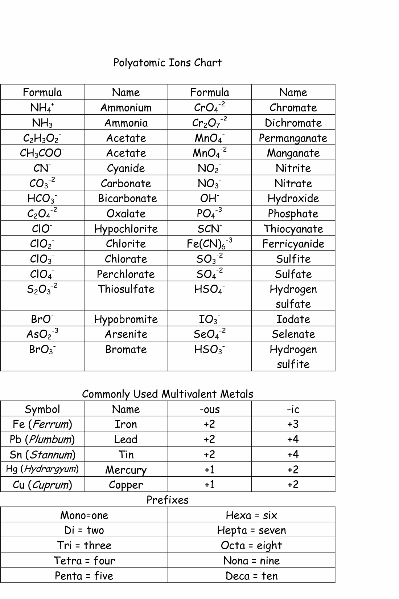

Downloaded from http://www.tidyforms.com

